# Assignment – 2 Python Programming

|  |  |
| --- | --- |
| Assignment Date | 15/11/2022 |
| Student Name | Ramakrishnan P |
| Student Roll Number | 95071912072 |

1. **Create a User table with Username, email, roll number, password**

# Perform UPDATE and DELETE queries

1. **Connect python code to database**

# Create Flask app for a User registration and User login Solution:

## App.py

from flask import Flask, render_template, request, redirect import sqlite3 as sql

import models as dbHandler app = Flask( name ) app.secret_key = 'fasdgfdgdfg' @app.route('/')

def home():

return render_template('home.html') @app.route('/adduser')

def new_user():

return render_template('add_user.html') @app.route('/addrec',methods = ['POST', 'GET']) def addrec():

if request.method == 'POST': try:

email = request.form['email'] un = request.form['username'] rn = request.form['rollnumber'] pin = request.form['pin']

with sql.connect("User_database.db") as con:

cur = con.cursor()

cur.execute("INSERT INTO users (email,username,rollnumber,pin) VALUES (?,?,?,?)",(email,un,rn,pin) )

con.commit()

msg = "Record successfully added!" except:

con.rollback()

msg = "error in insert operation" finally:

return render_template("list.html",msg = msg) con.close()

@app.route('/list') def list():

con = sql.connect("User_database.db") con.row_factory = sql.Row

cur = con.cursor() cur.execute("select * from users") users = cur.fetchall()

return render_template("list.html", users = users) if name == ' main ':

app.run(debug = True) @app.route("/delete") def delete():

return render_template("delete.html") @app.route('/deleterecord',methods = ["POST"]) def deleterecord():

un = request.form['username']

with sql.connect("User_database.db") as con: try:

cur = con.cursor()

cur.execute("DELETE FROM users WHERE username = ?",[un]) con.commit()

msg = "Record successfully deleted" except:

msg = "can't be deleted" finally:

return render_template("home1.html",msg = msg) if name == ' main ':

app.run(debug = True) @app.route('/deldb', methods = ["POST"]) def deldb():

con = sql.connect('User_database.db') cur = con.cursor() cur.execute('DELETE FROM users;') con.commit()

con.close()

msg = 'All the data has been deleted'

return render_template("home1.html",msg = msg) @app.route("/log")

def log():

return render_template("login.html") @app.route('/login', methods =['GET', 'POST']) def login():

un = request.form['username'] if request.method=='POST':

users = dbHandler.retrieveUsers() msg = 'Logged in successfully!'

return render_template('welcome.html', users=un, msg=msg) else:

msg = 'You are not registered, would you like to be registered' return render_template('home1.html', msg=msg)

if name == ' main ':

app.run(debug=False, host='0.0.0.0')

## Models.py

import sqlite3 as sql def retrieveUsers():

con = sql.connect("User_database.db") cur = con.cursor()

cur.execute("SELECT username, pin FROM users") users = cur.fetchone()

con.close() return users

## sqlite_db_setup.py

import sqlite3

conn = sqlite3.connect('User_database.db') print("Opened database successfully")

conn.execute('CREATE TABLE users (email TEXT, username TEXT, rollnumber INTEGER, pin INTEGER)')

print("Table created successfully") conn.close()

## Home.html

<h1>Welcome to User Database APP</h1><br><br>

<a href="/">HOME</a><br><br>

<a href="/adduser">User Registration</a><br><br>

<a href="/list">List User</a><br><br>

<a href="/log">Log in</a><br><br>

<a href="/delete">Remove a User</a>

## Add_user.html

<form action = "{{ url_for('addrec') }}" method = "POST">

<h3>User Information</h3> E-mail<br>

<input type = "email" name = "email" /></br> Username<br>

<input type = "text" name = "username" /></br> Rollnumber<br>

<input type = "text" name = "rollnumber" /><br> PIN<br>

<input type = "password" name = "pin" min="4" max="8" /><br><br>

<input type = "submit" value = "submit" /><p> </p>

<input type = "reset"/>

</form>

## list.html

<!doctype html>

<html>

<body>

<a href="/">HOME</a><br><br>

<a href="/adduser">Add New Student</a><br><br>

<a href="/list">List Student</a><br><br>

<br><hr>

{{ msg }}

<table border = 1>

<thead>

<td> Email </td>

<td> Username </td>

<td> Roll Number </td>

<td> Pin </td>

</thead>

{% for row in users %}

<tr>

<td>{{row["email"]}}</td>

<td>{{row["username"]}}</td>

<td> {{ row["rollnumber"]}}</td>

<td>{{row['pin']}}</td>

</tr>

{% endfor %}

</table>

</body>

</html>

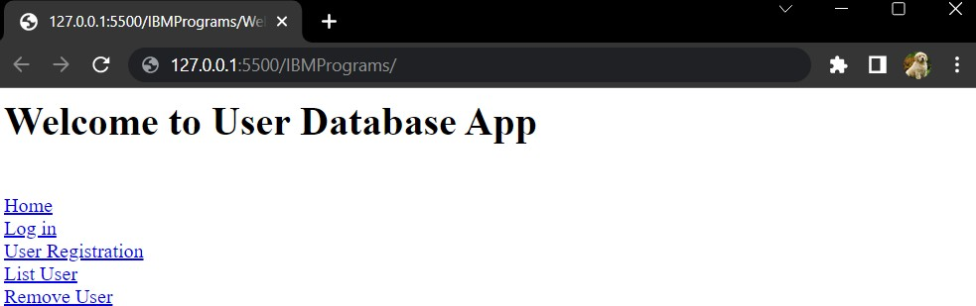

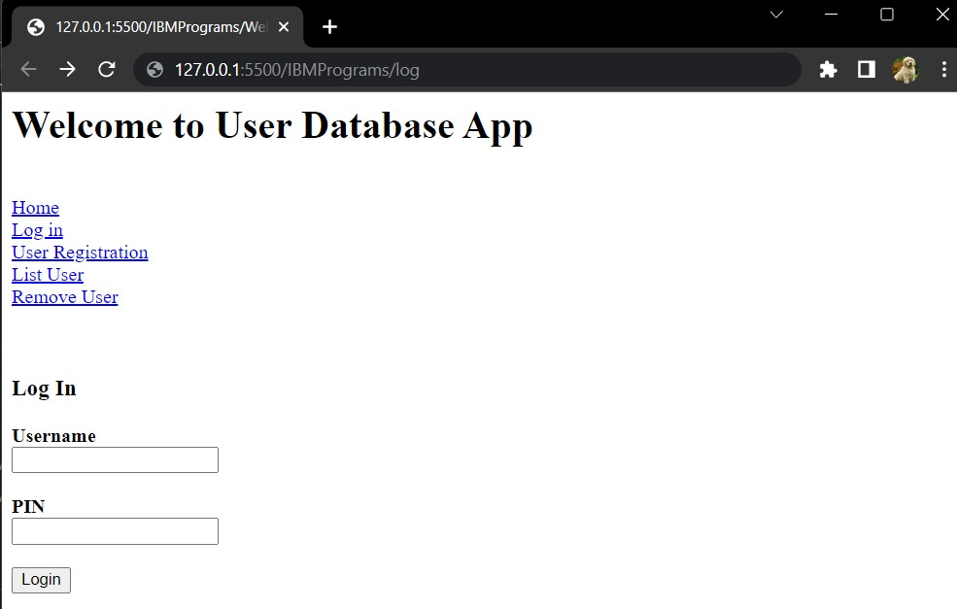

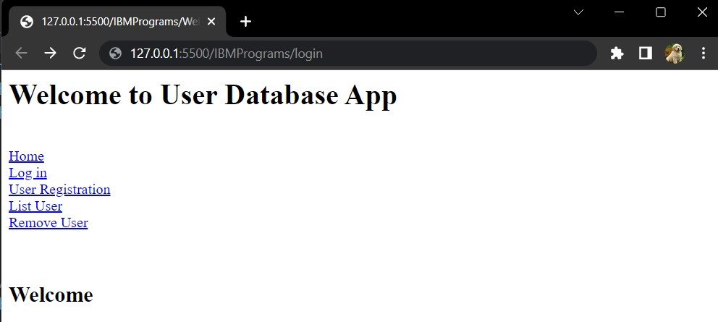

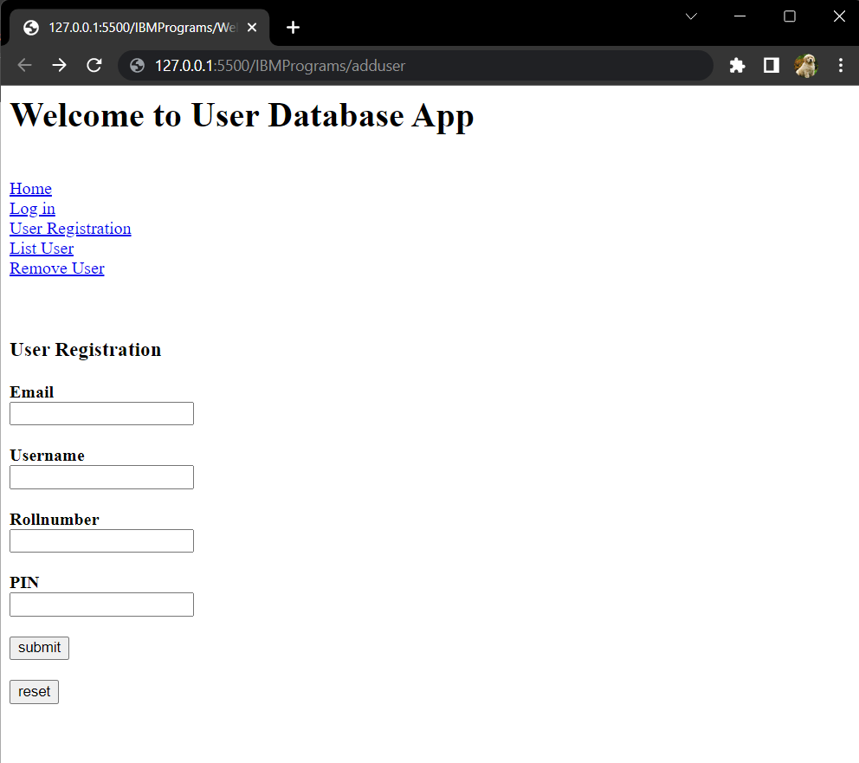

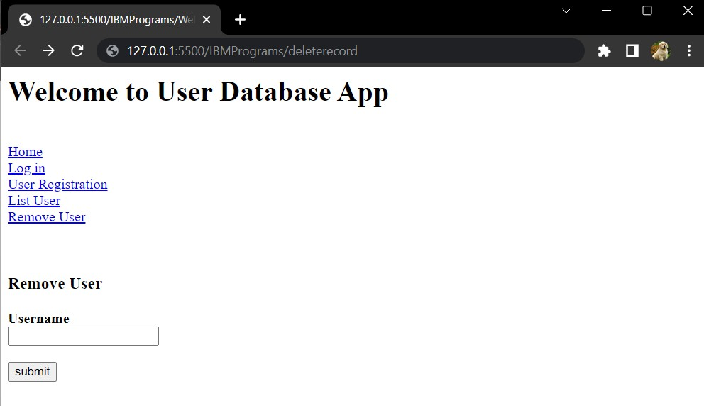

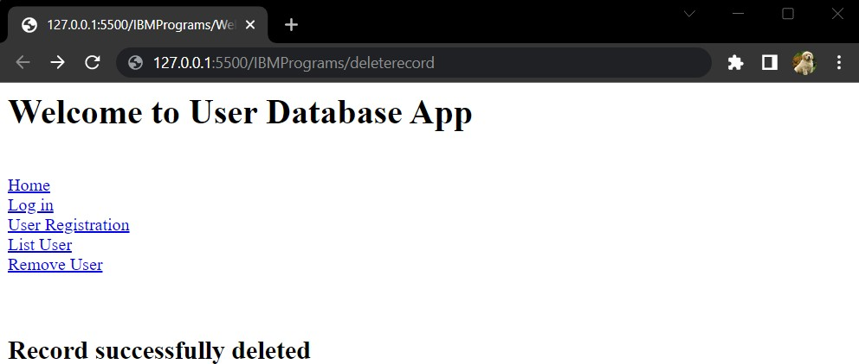

|  |  |  |  |
| --- | --- | --- | --- |
| Email | Username | Roll | PIN |
| Ramakrishnanp699@gmail.com | Ramakrishnan P | 95071912072 | 2370 |
| Sundaramva99@gmail.com | Sundaram VA | 95071912099 | 5524 |